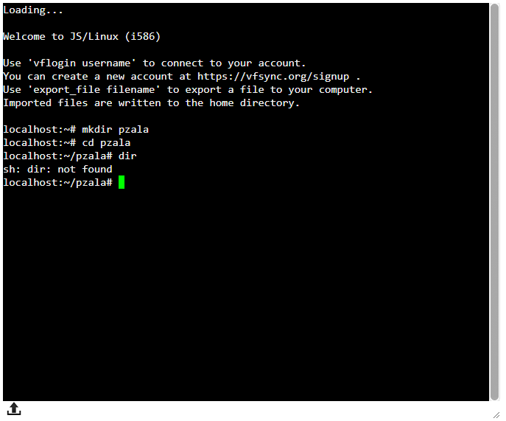

1) mkdir pzala

2) cd pzala

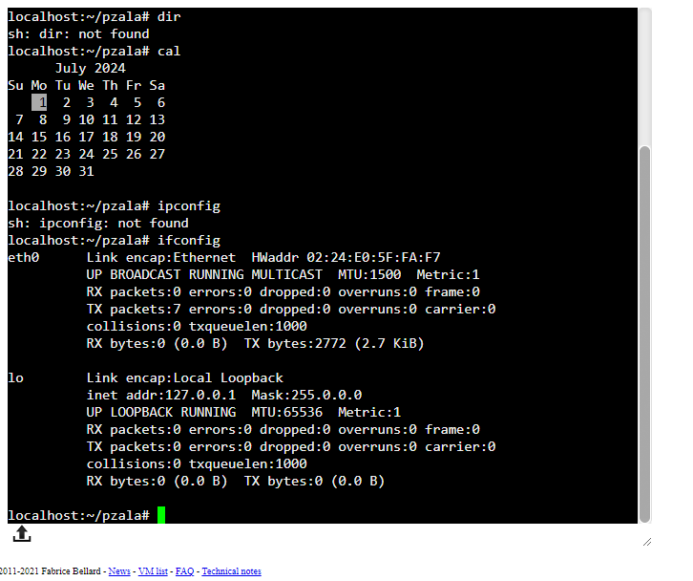

3)cal

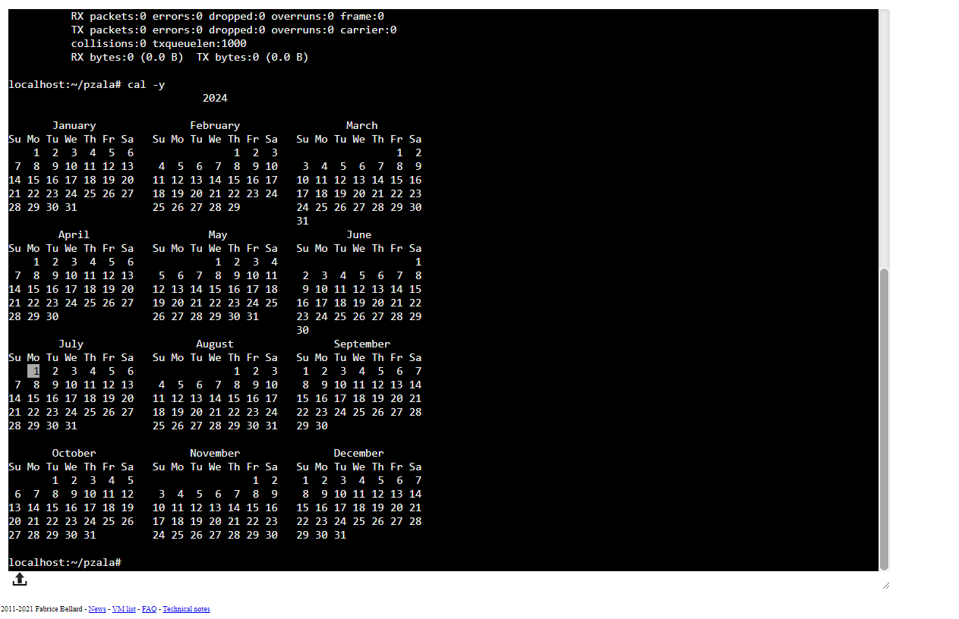

4)cal -y

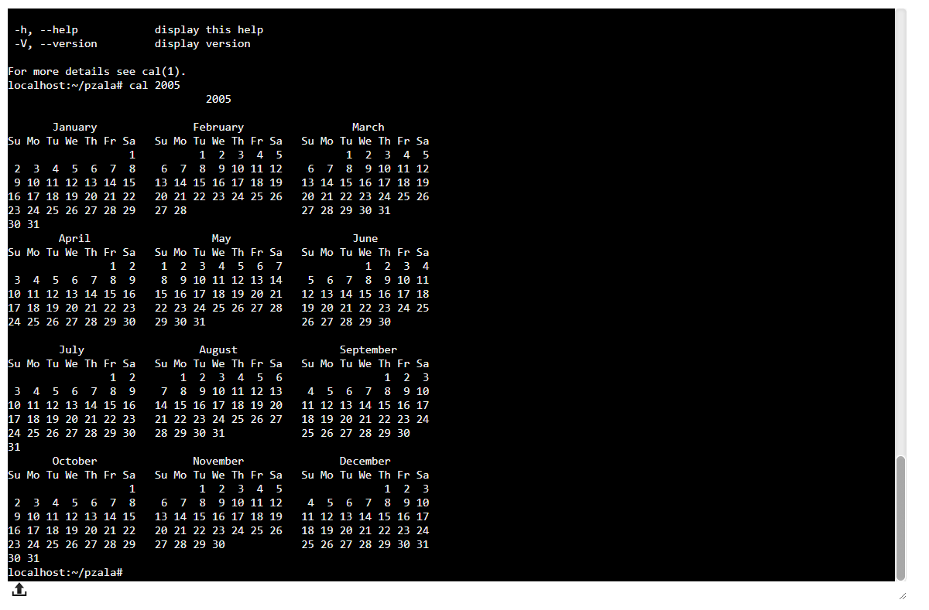

5) cal 2005

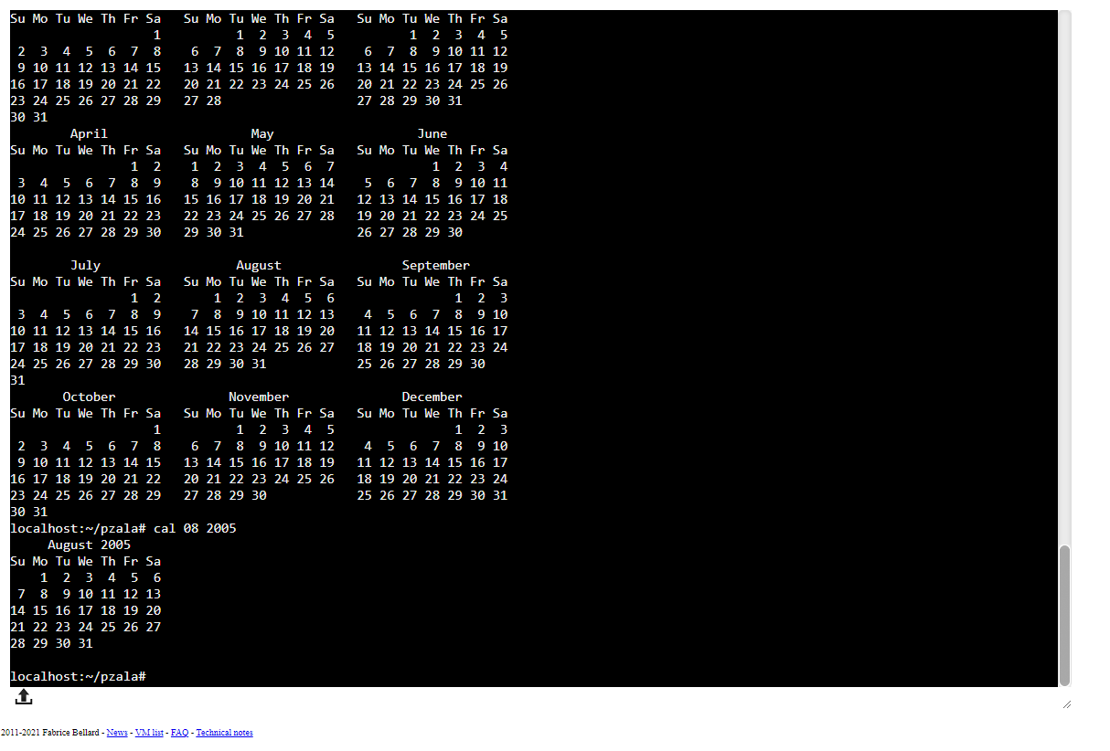

6) cal 08 2005

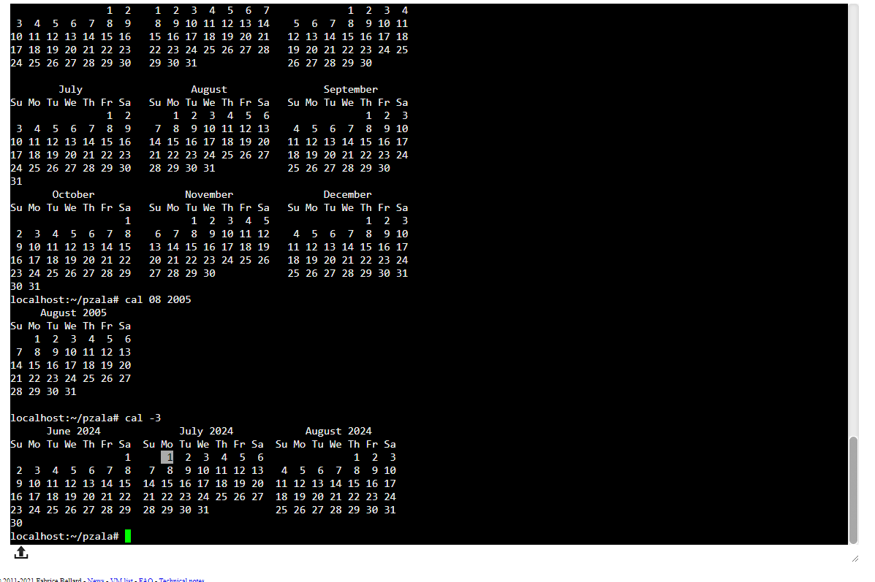

7) cal -3

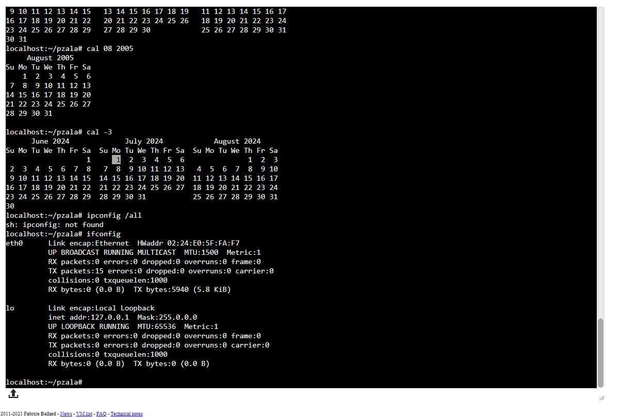

8) ifconfig / ipconfig/all

|  |  |
| --- | --- |
| 1)mkdie pzala  2) cd pzala | Capture.PNG |
| 3) cal | Capture2.PNG |
| 4) cal -y | Capture3.PNG |
| 5)cal 2005 | Capture4.PNG |
| 6)cal 08 2005 | Capture5.PNG |
| 7) cal -3 | Capture6.PNG |
| 8) ipconfig/ifconfig | Capture7.PNG |
| 9) passwd | Capture.PNG |
| 10)ls | Capture2.PNG |
| 11) ls -l | Capture3.PNG |
| 12) ls -a | Capture4.PNG |
| 13)ls -la | Capture5.PNG |
| 14)whoami | Capture6.PNG |
| 15)clear | Capture7.PNG |